### **Day-13 (Dictionary)**

**Q1. Write a Python program and calculate the mean of the below dictionary.**

**test_dict = {"A" : 6, "B" : 9, "C" : 5, "D" : 7, "E" : 4}**

**Sol:**

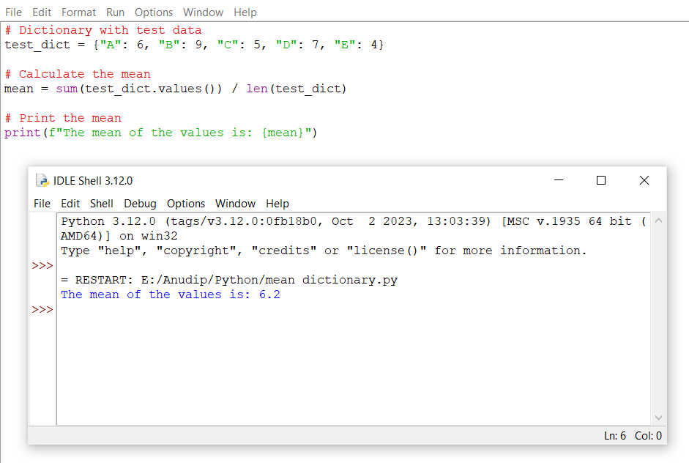

**Q2. Write a Python script to concatenate the following dictionaries to create a new one.**

**Sample Dictionary : dic1={1:10, 2:20} dic2={3:30, 4:40} dic3={5:50,6:60}**

**Expected Result : {1: 10, 2: 20, 3: 30, 4: 40, 5: 50, 6: 60}**

**Sol:**

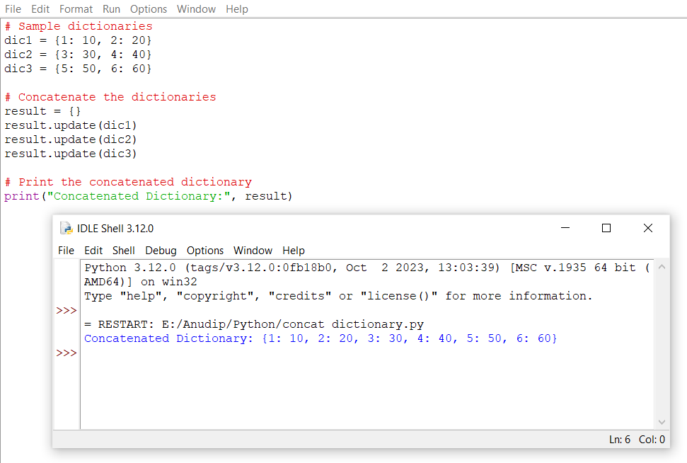

**Q3.Write a Python program to get the key, value and item in a dictionary.**

**input:dict_num = {1: 10, 2: 20, 3: 30, 4: 40, 5: 50, 6: 60}**

**Sol:**

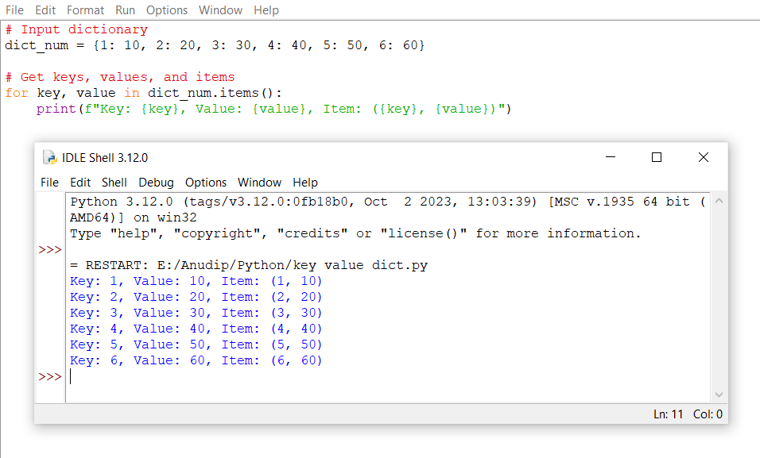

**Q4.Write a Python program to get the key, value and item in a dictionary.**

**Input: input_dict = {1: 10, 2: 20, 3:None, 4: 40, 5: None, 6: 60}**

**Sol:**

